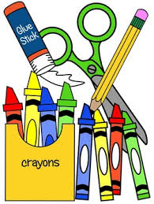**Goshen Elementary Pre-K “Wish List”**

**2025 – 2026**

**Required:**

**Change of clothes: shirt, pants, socks, and undies**

**(labeled with child’s name and in a Ziploc bag)**

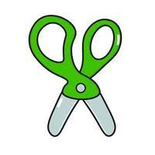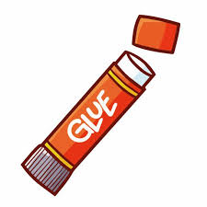**Also need:**

**Rest mat and book bag (full-size)**

2 boxes of 24 Crayola crayons

2 packs of Crayola washable markers

Pack of pencils

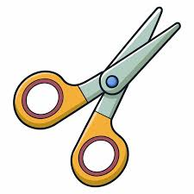Pack of colored pencils

2 composition books

1 box of Expo dry erase markers

2 pack of playdough

2 boxes Kleenex

2 packs of baby wipes

Large hand sanitizer

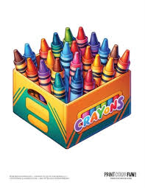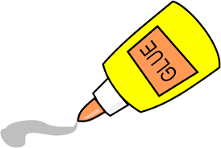Quart Ziploc bags

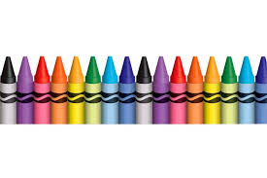Sandwich Ziploc bags